Activity S2H Area
👳🏻‍♀ Farmer Meeting👳🏻‍♀
RMO PATNA

- Village: Sewahi
- District: Rohtash
- Focused Crops- Paddy🌾

Attendent By-
AMM - Ashish Pratap Singh HQ:-(Sasaram)

Participating Channel Partners:🌿🌿

Retailers - Dharmendra khad bhandar

Proprietor Name :- Dharmendra Singh
Location:- Sewahi
Mobile - 9708793382

Attendance:
More than 50farmers participated in meeting.

Topics Discussed during the Farmer meeting:

1. Company introduction.
2. S2H Project and Our services and discussed about our products.
CPC :- Onvix, Pevota, Azole, Metroz, Fillip Agros, Mozo. Pretilaveer etc.

SN :- Sulton, Superrhiza, Sulfino Gold, etc.

3. Importance of soil testing, balanced fertilizer usage, & its importance, and the importance and usage of Bio- Fertilizers etc.
4. Importance of Superrhiza, in Paddy crops.
5. Addressed general and technical queries of farmers and provided them precise solutions.

The meeting was organized by :
*Mr. Arunish kumar
*UKS Rohtash Activity S2H Area 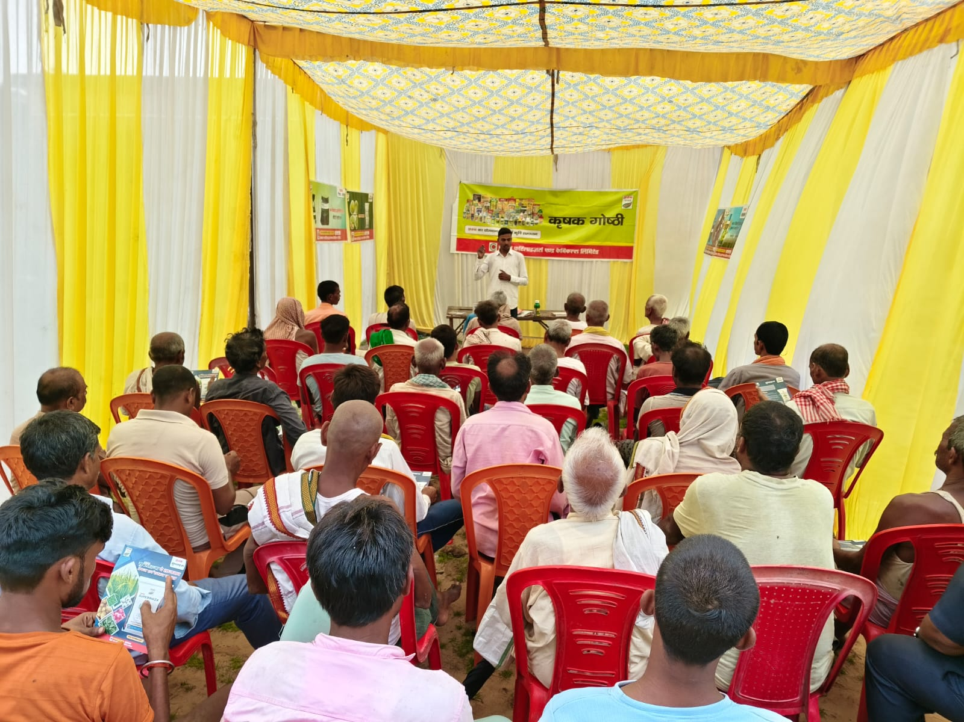

👳🏻‍♀ Farmer Meeting👳🏻‍♀
RMO PATNA

- Village: Huruka
- District: Rohtash
- Focused Crops- Paddy🌾

Attendent By-
AMM - Ashish Pratap Singh HQ:-(Sasaram)

Participating Channel Partners:🌿🌿

Retailers - New kisan khad bhandar
Location - Sewahi Road Pathara

Mobile- 7255004386

Attendance:
More than 30 Farmer participated in meeting.

Topics Discussed during the Farmer meeting:

1. Company introduction.
2. S2H Project and Our services and discussed about our products.
CPC :- Onvix, Pevota, Azole, Metroz, Fillip Mozo. Pretilaveer Agros etc.

SN :- Sulton, Superrhiza, Sulfino Gold, etc.

3. Importance of soil testing, balanced fertilizer usage, & its importance, and the importance and usage of Bio- Fertilizers etc.
4. Importance of Superrhiza, in Paddy crops.
5. Addressed general and technical queries of farmers and provided them precise solutions.

The meeting was organized by :
*Mr. Arunish kumar
*UKS Rohtash

Activity S2H Area
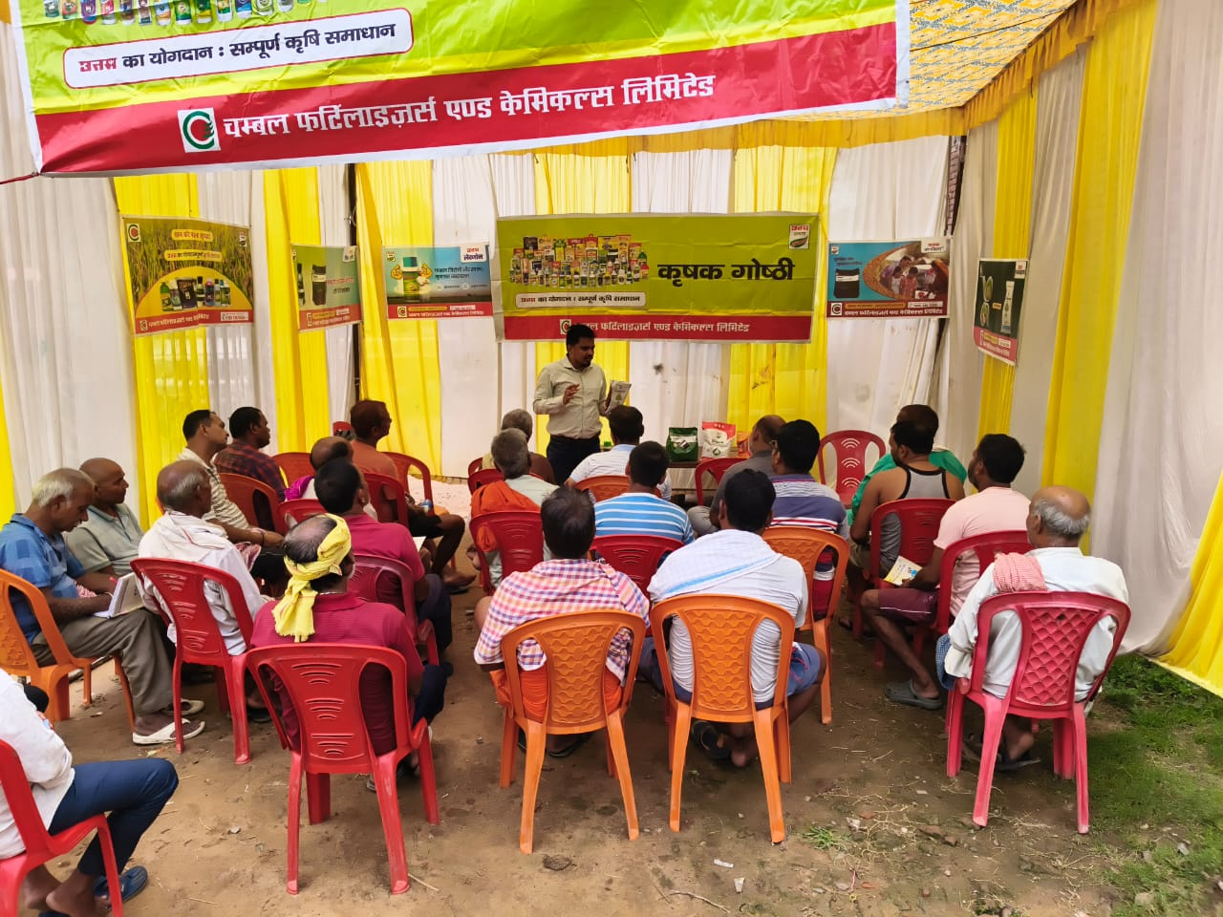

👳🏻‍♀ Farmer Meeting👳🏻‍♀
RMO PATNA

- *Village: Harnachiti
- *District: Rohtash
- *Focused Crops- Paddy,

Participating Channel Partners:🌽🌽🌽🌽

Attendent By-
AMM - Ashish Pratap Singh
Retailers -

1.
Dhiraj enterprises
ProprietorName :- Dhiraj Kumar
Location:-Harnachiti
Mob:- 6204918844

Attendance:
More than 50 farmers participated in meeting.

Topics Discussed during the Farmer meeting:

1. Company profile, Vision
2. S2H Project and Our services and discussed about our products.
*CPC :- Pretilaclor Pevota,Onvix,lexon, Azole etc.

SN :- Sulton, Superrhiza, Sulfino Gold, etc.

3. Importance of soil testing, balanced fertilizer usage, & its importance, and the importance and usage of Bio- Fertilizers etc.
4. Importance of Superrhiza, in All crops.
5. Addressed general and technical queries of farmers and provided them precise solutions.

The meeting was organized by :
*Mr. Arunish kumar
*UKS Rohtash
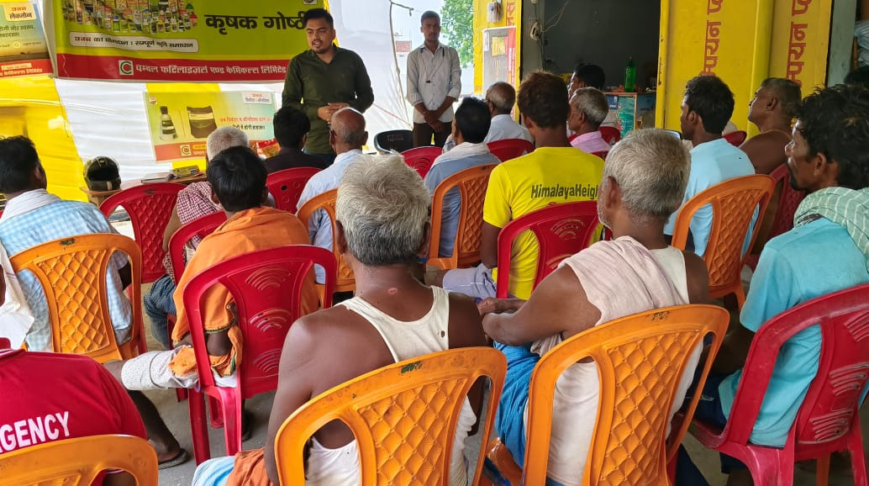

*Date:-8/07/2025
Activity S2H Area
👳🏻‍♀ Farmer Meeting👳🏻‍♀
RMO PATNA

- *Village:-Baradih
- *District: Rohtash
- *Focused Crops- Paddy,

Participating Channel Partners:🌽🌽🌽🌽

Attendent By-
AMM - Ashish Pratap Singh
Retailers -

1.
Dhiraj enterprises
ProprietorName :- Dhiraj Kumar
Location:-Harnachiti
Mob:- 6204918844

Attendance:
More than 50 farmers participated in meeting.

Topics Discussed during the Farmer meeting:

1. Company profile, Vision
2. S2H Project and Our services and discussed about our products.
*CPC :- Pretilaclor Pevota,Onvix,lexon, Azole etc.

SN :- Sulton, Superrhiza, Sulfino Gold, etc.

3. Importance of soil testing, balanced fertilizer usage, & its importance, and the importance and usage of Bio- Fertilizers etc.
4. Importance of Superrhiza, in All crops.
5. Addressed general and technical queries of farmers and provided them precise solutions.

The meeting was organized by :
*Mr. Arunish kumar
*UKS Rohtash
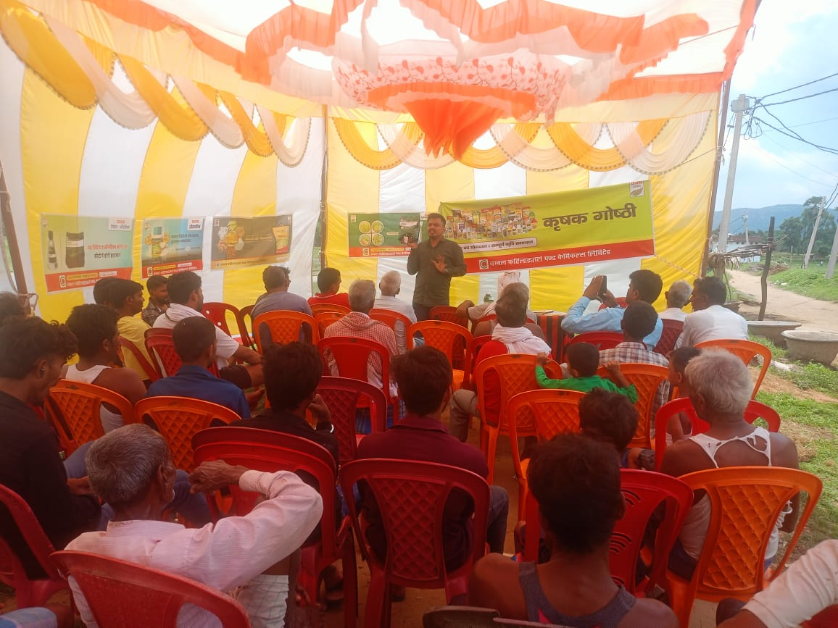

*Date:-8/07/2025 Activity S2H Area
👳🏻‍♀ Farmer Meeting👳🏻‍♀
RMO PATNA

- Village: Chanka
- District: Rohtash
- Focused Crops- Paddy🌾

Participating Channel Partners:🌿🌿

Attendent By-
AMM - Ashish Pratap Singh HQ:-(Sasaram)

Retailers -
1)
ProprietorName :- Niraj Kumar Singh
Location:- Jakhini Mod
Mobile -8986109128

Attendance:
More than 80farmers participated in meeting.

Topics Discussed during the Farmer meeting:

1. Company introduction.
2. S2H Project and Our services and discussed about our products.
CPC :- Onvix, Pevota, Azole, Metroz, Fillip Mozo. Pretilaveer etc.

SN :- Sulton, Superrhiza, Sulfino Gold, etc.

3. Importance of soil testing, balanced fertilizer usage, & its importance, and the importance and usage of Bio- Fertilizers etc.
4. Importance of Superrhiza, in Paddy crops.
5. Addressed general and technical queries of farmers and provided them precise solutions.

The meeting was organized by :
*Mr. Arunish kumar
*UKS Rohtash
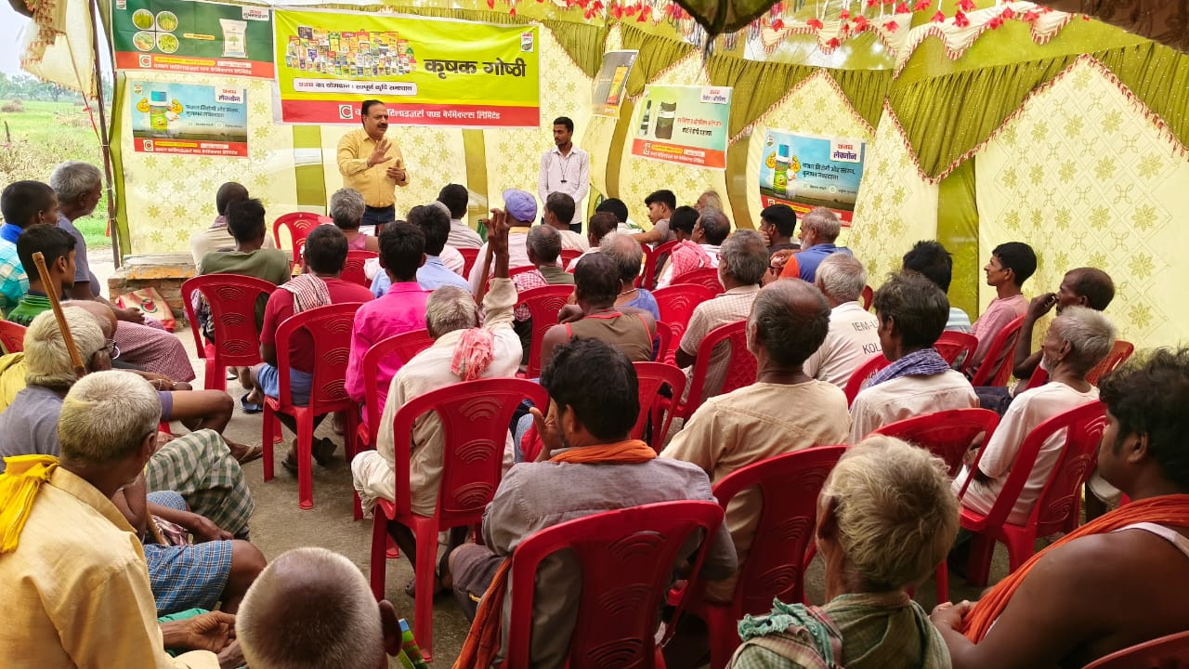

Activity S2H Area
👳🏻‍♀ Farmer Meeting👳🏻‍♀
RMO PATNA

- Village: Nawadih
- District: Rohtash
- Focused Crops- Paddy🌾

Participating Channel Partners:🌿🌿

Attendent By-
AMM - Ashish Pratap Singh HQ:-(Sasaram)

Retailers - Priyanshu khad bhandar
Location:- Nimiyadih Mobile -+918873274362

Attendance:
More than 60farmers participated in meeting.

Topics Discussed during the Farmer meeting:

1. Company introduction.
2. S2H Project and Our services and discussed about our products.
CPC :- Onvix, Pevota, Azole, Metroz, Fillip Mozo. Pretilaveer etc.

SN :- Sulton,Superrhiza, Sulfino Gold,etc.
3. Importance of soil testing, balanced fertilizer usage, & its importance, and the importance and usage of Bio- Fertilizers etc.
4. Importance of Superrhiza, in Paddy crops.
5. Addressed general and technical queries of farmers and provided them precise solutions.
The meeting was organized by :
*Mr. Arunish kumar
*UKS Rohtash

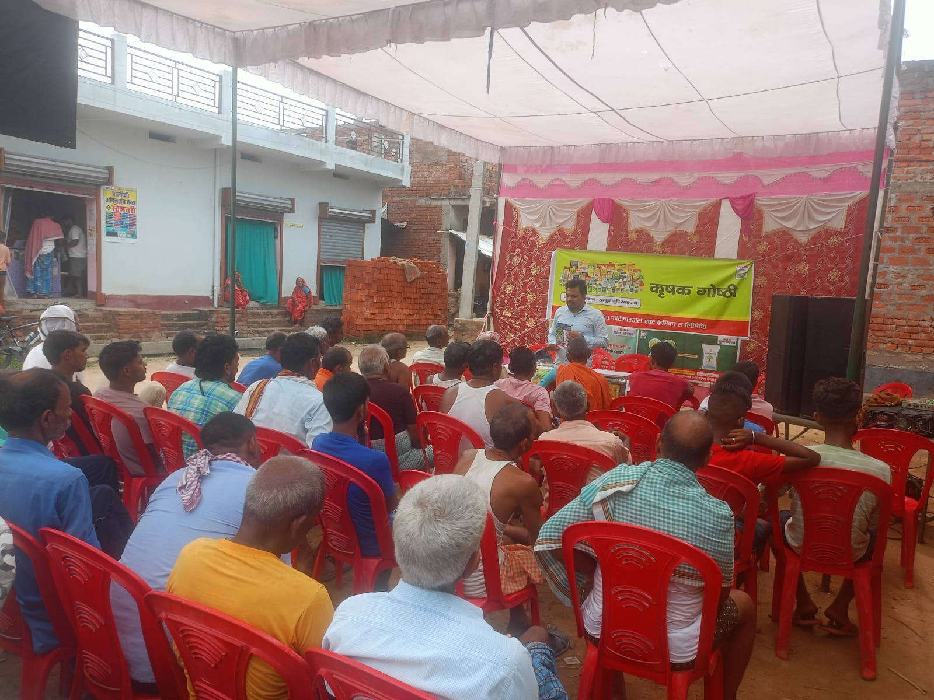

Activity S2H Area
👳🏻‍♀ Farmer Meeting👳🏻‍♀
RMO PATNA
- Village: Kushdihra
- District: Rohtash
- Focused Crops- Paddy🌾
Participating Channel Partners:🌿🌿*
Attendent By-
AMM - Ashish Pratap Singh HQ:-(Sasaram)

Retailers - Mayank khad bhandar Huruka
Location:- Nimiyadih Mobile -+919708884201

Attendance:
More than 40farmers participated in meeting.

Topics Discussed during the Farmer meeting:

1. Company introduction.
2. S2H Project and Our services and discussed about our products.
CPC :- Onvix, Pevota, Azole, Metroz, Fillip Mozo. Pretilaveer etc.

SN :- Sulton,Superrhiza, Sulfino Gold,etc.
3. Importance of soil testing, balanced fertilizer usage, & its importance, and the importance and usage of Bio- Fertilizers etc.
4. Importance of Superrhiza, in Paddy crops.
5. Addressed general and technical queries of farmers and provided them precise solutions.
The meeting was organized by :
*Mr. Arunish kumar
*UKS Rohtash
